USB Remote Software

Instruction Manual

Arlyn Scales
59 Second Street
East Rockaway, NY 11518
(516) 593-4465
www.arlynscales.com
Rev 2.0

Contents

Introduction and Overview 3
Features 3
System Requirements 3
Installation - Quick-Start 3
Configuring Your Scale Indicator for USB 4
Operational Overview 4
Data Collection 6
Scale Configurations and Defaults 6
Automatic Polling vs. Print at Stability 7
Using RS232 Capable Scales With This Software 7
RS232 Configuration Screen 7
Installing the USB Drivers 8
Installing Remote Indicator Software 9
License Agreement – Technical Support 10

Introduction and Overview
Thank you for purchasing the USB Remote Software Package for your Arlyn Scale. You may use this to connect up to ten USB capable scale indicators to a single PC. Included is the USB Remote Windows Software and drivers, which will allow you to switch between scales while live readings are taking place. A faceplate similar to the scale’s faceplate is shown on the screen and all of the keys are live. Clicking the key on the screen will cause the scale to perform the same function as if you had pressed the key on the scale itself, giving you full remote capability.

There is also a data collection function that will capture readings, and store them in a Microsoft Access compatible database. This Access Database is a stand-alone file (SCDATA.MDB) that is not protected or encrypted in any way. Microsoft Access 2.0 was purposely chosen so that users with more up to date versions of Access will have no trouble attaching to, or importing data from it.

Another screen allows you to view the readings that were collected, and easily separate data from multiple scales. You can also export the data to a CSV (comma separated values) text file that can then be imported into a number of popular Windows software packages.

The actual connection is made directly to the USB port on your computer. On most computers there are generally only two USB ports available and are sometimes already committed to external disk drives and other peripherals. In these cases, or in cases where you wish to hook up more than two scales, a USB expander hub may be used. These are widely available in many computer stores.

Features

- Easy installation and operation
- Automatic USB scan and scale configuration
- Complete remote keyboard capability
- Data collection with statistical analysis

- Data separation and export capability
- Plug and play compatibility
- USB is self powered, no power from your PC is required
- Up to ten scale indicators may be connected

System Requirements
Before proceeding, please read and understand the chapter entitled “License Agreement – Technical Support”.
The drivers and their authors dictate the system requirements. Arlyn has no control over the update path or future availability of these drivers.

- A computer with USB capability. One free USB port is required for each scale. A USB expander hub may be used.
- Microsoft Windows XP, 98, 2000, or ME Operating System (Windows Vista is not supported)
- 5 Megabytes of free hard drive space

Installation - Quick-Start
To get up and running quickly, perform the following procedure:

- Configure your scale indicator as per the section entitled “Configuring Your Scale Indicator for USB”.
- Install the USB hardware drivers by completing the section “Installing the USB Drivers”, and then reboot your PC.
- Download the USB Remote Indicator Software and Drivers from https://www.arlynscales.com/downloads.php
- Install the USB Remote Indicator Software by completing the section “Installing Remote Indicator Software”.
- Press the On/Off button to bring the scale indicator into its main weighing screen.
- Click on Start->All Programs->Arlyn Scales->Remote Indicator 2.5->Launch Remote Indicator 2.5.
- On the Menu bar, on the main screen of the Remote Indicator, click on “Activate Remote Screen”.
- A screen showing a scale faceplate similar to the one on your indicator is shown and in a moment live reading will be shown on the screen.

Configuring Your Scale Indicator for USB
Your scale indicator must be configured properly for it to communicate with its internal USB controller. The actual communication is done through an RS232 link between the scale’s main processor and the USB controller. Ant scale purchased from Arlyn Scales with a USB option will have this setup completed prior to shipping from the factory. If the settings have been changed, or otherwise lost, you can recreate them using the procedure below. Please refer to the Options Manual for editing RS232 setups.

- Add a single print frame.
- Edit the print frame so that is has only one line in it, with the following parameters:
FUNCTN = Weight, SOURCE = Plat#001, C = Checked, L = Checked, SP = 0
- Save the print frame.
- In the print frames list, make sure that the frame is activated by placing a check mark next to it.
- Modify the port configuration to have the following parameters:
BAUD = 9600, DATA BITS = 8, STOP BITS = 1, PARITY = None, ECHO = Off

During normal use, the scale should be in one of its main weighing screens. The indicator will not send RS232 signals while it is in a menu, or anything other than its main weighing screen.

Operational Overview
When the USB Remote Software is first started, you will be shown a blank screen with a number of menu items available. The software is now in its “Standby State”. The three menus that are available are File, Activate Remote Screen, Tools, Help and Exit.

Click on the menu item called Activate Remote Screen. When you do this, a number of things happen. First, the USB is scanned for any Arlyn Scales that may be attached to it. The program will then search its configuration records to find records, whose serial numbers match those that were scanned on the USB. If it finds those records it will load them, examine the previous configuration that was stored in that record and then configure the scale and the USB appropriately.

If this is the first time that the scale has been attached to the USB, there will be no configuration record for it. The program will then add a configuration record for this scale and assign it default values. Then it will link up with the scale and configure it appropriately. The default values for new scale configuration records can be modified and saved. This will be covered later.

The Scale screen is similar to the one shown here. You will notice that it has a keyboard and display almost identical to the scale, and live readings will be displayed.

To the right of the weight display there is a pull down box listing all of the Arlyn Scales that were detected on the USB. To switch from one scale to another simply pull down the list and select the desired scale. The description of each scale, in part, is its serial number. This number can be found on the rear face of most Arlyn indicators. The serial number of the scale is automatically uploaded to the USB port on start-up.

Below the pull down list, there is a frame box describing the Operating Mode.

OPERATING MODE
The Operating mode frame has four specifications; Single, Network, Enable Polling and Poll/Net Time.

- Single
  - Choose Single if you have a single scale connected to your USB port. If you have a network of scales connected to your USB port, choose this option if you only want to poll one scale in that network.

- Network
  - Choose Network ONLY if you have a network of scales connected to your USB port.

- Enable Polling
  - Placing a checkmark in front of this specification will continuously update the weight on the screen in intervals specified under Poll/Net Time specification. Once a checkmark is placed here, no further action is required from the user to update the weight screen.
  - Removing a checkmark in front of this specification will enable manual update of the weight screen. Now the weight will only be updated if the user presses the Print Key on the Arlyn Scale Front Panel.

- Poll/Net Time
  - This is how often the USB Software requests readings from the scale. This specification is synonymous with the Enable Polling specification. The time specified here is the interval time between two subsequent readings. It will determine how fast the scale will be polled for new readings.

WEIGHT RECORDING
Below the Operating mode frame, there is an Enter Weight button. Pressing this button will record the current weight on the screen on to a table displayed on the left of the panel. New Readings will be added to the table each time the Enter Weight button is pressed.
In Remote Indicator version 2.4, a checkbox is available above the Enter Weight button named Auto Entry Mode. When this checkbox is marked, and the Enable Polling checkbox is also marked, the weight will be entered automatically in the table each time the weight screen is updated. The timing of this feature also depends on the Poll/Net Time. This feature is yet to be implemented in the new release of the software (version 2.5).

The collection record includes the scale’s ID, the weight, the time and the date that the reading was taken. If time and date are important in your application, ensure that the system time and date on your computer is set accurately.

EXPORTING DATA
Clicking on Export Table will export the table shown in to a Comma Separated List file (.CSV). This file can be opened using Microsoft Excel or any Spreadsheet Application of preference.

On the other hand, clicking on the Clear Table button will clear the table completely.

REMOTE KEYPAD
The keyboard shown will emulate all normal keystroke presses as if they were pressed on the scale’s indicator itself. This keyboard, although fully functional will sometimes behave sluggishly depending on how the scale is configured and the rate at which the software requests readings from the scale. Just click on them slowly with your mouse and the key will activate. You may also key your way into the scale’s menu system and navigate around within it. The screen on your computer will not show the menu, and it must be viewed on the scale itself. The display update will stop while any menu is activated.

Data Collection
When activated for a particular scale, data will be collected and saved to a Microsoft Access database file located in the USB Software’s installation directory. The name of the file is RIDATA.MDB. RIDATA.MDB contains only a single table called DataCol. There are five fields within DataCol. These are ID (record counter), ScaleID (scales description), Reading, Time and Date. This MDB file is not protected or encrypted in any way. One may import this table into any database application that is compatible with Microsoft Access to generate data queries, reports and the like.

Access, although updated many times throughout the years, was chosen specifically for this software. This allows anyone running later versions of Access to easily attach to, or import the table without having to worry about version conflicts. Microsoft Access has been upward compatible since its inception.

Clicking the Clear List button will completely empty the table.

Scale Configurations and Defaults
As mentioned in an earlier section, the software maintains a configuration record for all the Arlyn Scales that are attached, or have ever been attached to it. These configuration records control whether the scale is active (yes, you can make any scale inactive), how often the software polls the scale for readings, and the speed (baud rate) at which the scales internal USB controller communicates with the scale’s main processor.

If the software detects a new scale on the USB, one that a configuration record doesn’t exist for yet, it will create one based on the defaults specified in the scale configuration screen. The defaults are factory set to have the scale active, poll readings each 1.0 second and internal communications set to 9600 baud.

To modify a scale’s configuration, start by opening the Scale Configuration Screen. Select Tools from the main menu, and then select Setup. Use the navigation buttons to line up on the desired record, make whatever changes you like and then click the update button. You will notice the default values for new records on the lower half of the screen. This screen cannot be loaded while the Remote Screen is open. That screen must be closed before any configuration changes are made. This is because the USB scanning, configuration and record maintenance is done upon activation of the Remote Screen.

Automatic Polling vs. Print at Stability
As mentioned above, data from the scale is requested on a timed basis. This is not ideal in every situation. There are two other possibilities regarding initiating data transfers between scale and computer.
Print On Demand

If you would like the data to be transmitted only when needed, you can set it up to not poll automatically, and instead the Print Button on the scale can be used to initiate the transfer. Simply go into the scale configurations in this software and set the poll time for the desired scale to 0 and save. The next time you go to the remote window you will not see any readings until you press the print button on the scale’s faceplate.
Print At Stability

There is a motion detect function in all Arlyn indicators that will transmit only if there is a stable weight on the platform that is greater than some preset threshold. This can be used to have the scale transmit the weight once the scale generates a stable reading.

The threshold weight along with two other configuration parameters can be setup in the scale’s menu system. Consult the main instruction manual for details on how to do this.

Using RS232 Capable Scales With This Software
Any Arlyn scale with an RS232 option installed can communicate with this software. This gives RS232 scales the capability of using the data collection and remote control features of this software. There are some points and limitations:

- Only one scale may be attached and recognized by the software.
- RS232 scales and USB scales cannot be used together.
- No special drivers are required for the RS232 interface. In fact, if you never plan to attach a USB scale to the system you may disregard installing USB drivers.
- The RS232 communications parameters as set in the scale’s option menu must be duplicated in the remote software package. The baud rate must match and the scale needs to be set to 8 data bits, 1 stop bit with no parity or echo..
- A pre-defined scale configuration already exists in the software, there is nothing to add.
- Time and date is recorded in the data collection database. The source of the time and date may be from your PC, or if the scale is equipped with a time and date option, it may come from the scale itself.
- Even though a pre-defined print frame is set in the scale prior to shipping, you may feel free to add to or modify it. The software will automatically pick up the weight reading (and time and date if configured) no matter where it is located in the output frame. You do need to avoid using any ASCII “+” or “-“ signs in your defined print frame (not including the one that prints with the reading). This will confuse the software rendering it incapable of finding the reading. If you must use it, then it must be output after the reading. This also applies to the time and date. In this case you can not use the ASCII characters “/” or “:”, and if so must be located after the time and date.

RS232 Configuration Screen
You can access this screen by selecting the View menu, then Setups, then Communications. It is pretty self-explanatory.

Make sure that Comm Type is set to RS232 and that the baud rate is correct. The program is limited to 8 data bits, one stop bit with no parity.

The scale indicator must also be set to these parameters.

These options should be set and saved. Quit the program, hook the scale up to the selected com port and restart the program.

Installing the USB Drivers
The first step in the installation is to install the USB drivers on your computer.

If you downloaded the drivers from our web site, unzip the downloaded file into a temporary directory on your computer or on a removable media (e.g. USB Flash Drive). A CD of drivers, Remote Indicator software and manual is also available from Arlyn Scales on a limited basis.

Apply power to the scale by plugging it into a wall outlet. The scale can be placed either in its normal weighing mode or at the “Ready” prompt.

Plug the USB cable from the indicator into the USB port on the back of the PC, or into the expander hub if you are using one.

The Windows Operating System will automatically detect the new USB device and attempt to find a driver for it. Select “Yes, this time only”.
Click Next.
In this dialog box, select “Install the software automatically (Recommended)”. Click Next.

Once the drivers have been installed successfully, this dialog box will appear showing the driver has completed installation. Click Finish to close it.
When this dialog box appears, the computer will install the drivers for your USB scale.

The next step is to install Remote Indicator Software.

Installing Remote Indicator Software
You can download the Remote Indicator software from the website or if you have a CD, the drivers will be present in that CD.

Unzip the Remote Indicator software into a temporary folder of your choice. Click on the .MSI file or the .EXE file, whichever the case. This begins your installation.

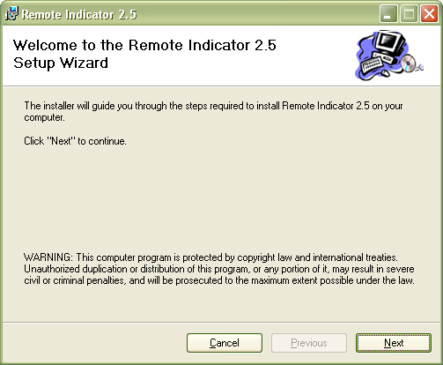
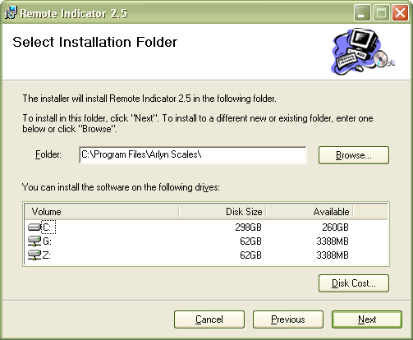
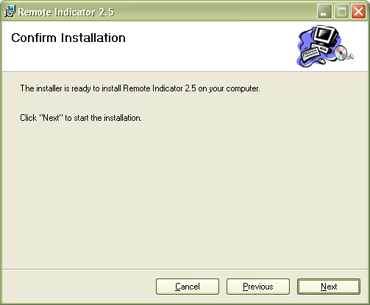
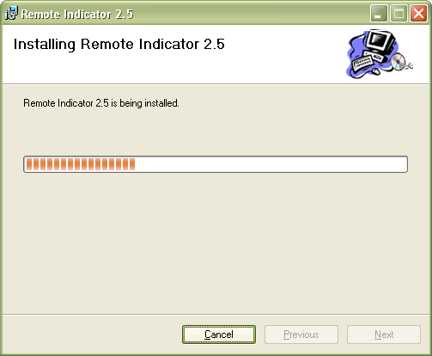
When you click the file as mentioned above, you will first encounter this dialog box. Click on Next to continue installation.
The installer will gather and uncompress the installation file onto a temporary folder and then show you this dialog box. The temporary folder will be deleted automatically after installation is complete. Simply click Next to continue.
In this dialog box, the prompt shows you available space in all the hard drives present on your system. Simply click Next to install the software in the default location (Recommended). Choose another location if you desire using the Browse button.
The software will now install the software in to your computer. The progress bar shows the status of the installation. Simply click Next on the next prompt that shows up.

License Agreement – Technical Support
Before installing this software, please read, understand and accept the following agreement:

This software and its drivers are only available through Arlyn Scales’ Web Site at http://www.arlynscales.com. Arlyn Scales doesn’t normally provide “Installation Disks”. All drivers and software should be downloaded from this site.

This software package is supplied free of charge “as is”. Arlyn Scales cannot, and will not offer technical support for the USB Remote Software. It was written simply as a service to our customers.

The actual USB drivers are written and distributed by FTDI or Silicon Labs, the makers of the USB controller chip that we use in our scale indicator. We have included the latest drivers from FTDI in this installation package. Future updates may be downloaded free of charge from their web site at http://www.ftdichip.com or http://www.silabs.com.

The drivers and their authors dictate the system requirements. Arlyn Scales has no control over the update path or future availability of these drivers. Given that the drivers were written elsewhere, we cannot support them to any realistic degree. We have found that the people at FTDI or Silicon Labs are very cooperative with technical issues. For driver related technical issues, we generally have to defer to them.

Arlyn Scales does not warrant, guarantee or make any representations regarding the use, or results of the use of the Software or accompanying materials in terms of correctness, accuracy, reliability, timeliness or otherwise. You assume all responsibility concerning selection of the software, and the ability to achieve the results you intend.

In no event shall Arlyn Scales, related companies, or its suppliers are liable for any damages whatsoever arising out of the use, or inability to use this software, even if Arlyn Scales has been advised of the possibilities of such damages.

By installing this software you acknowledge that you have read and agree to be bound by all of the terms of this agreement.

