USB Remote Software

Instruction Manual

Arlyn Scales
59 Second Street
East Rockaway, NY 11518
(516) 593-4465
www.arlynscales.com

Contents

Introduction and Overview 3
Features 3
System Requirements 3
Installation - Quick-Start 3
Configuring Your Scale Indicator for USB 4
Operational Overview 4
Data Collection 5
Scale Configurations and Defaults 5
Exporting Data 6
Installing the USB Drivers 7
License Agreement – Technical Support 8

Introduction and Overview
Thank you for purchasing the USB Remote Software Package for your Arlyn Scale. You may use this to connect up to ten USB capable scale indicators to a single PC. Included is the USB Remote Windows Software and drivers, which will allow you to switch between scales while live readings are taking place. A faceplate similar to the scale’s faceplate is shown on the screen and all of the keys are live. Clicking the key on the screen will cause the scale to perform the same function as if you had pressed the key on the scale itself, giving you full remote capability.
There is also a data collection function that will capture readings, and store them in a Microsoft Access compatible database. This Access Database is a stand-alone file (SCDATA.MDB) that is not protected or encrypted in any way. Microsoft Access 2.0 was purposely chosen so that users with more up to date versions of Access will have no trouble attaching to, or importing data from it.
Another screen allows you to view the readings that were collected, and easily separate data from multiple scales. You can also export the data to a CSV (comma separated values) text file that can then be imported into a number of popular Windows software packages.
The actual connection is made directly to the USB port on your computer. On most computers there are generally only two USB ports available and are sometimes already committed to external disk drives and other peripherals. In these cases, or in cases where you wish to hook up more than two scales, a USB expander hub may be used. These are widely available in many computer stores.

Features

- Easy installation and operation
- Automatic USB scan and scale configuration
- Complete remote keyboard capability
- Data collection with statistical analysis

- Data separation and export capability
- Plug and play compatibility
- USB is self powered, no power from your PC is required
- Up to ten scale indicators may be connected

System Requirements
Before proceeding, please read and understand the chapter entitled “License Agreement – Technical Support”
The system requirements are dictated by the drivers and their authors. Arlyn has no control over the update path or future availability of these drivers.

- A computer with USB capability. One free USB port is required for each scale. A USB expander hub may be used.
- Microsoft Windows 98, 2000 or ME Operating System
- 5 Megabytes of free hard drive space

Installation - Quick-Start
To get up and running quickly, perform the following procedure:

- Configure your scale indicator as per the section entitled “Configuring Your Scale Indicator for USB.
- Install the USB hardware drivers by completing the section “Installing the USB Drivers”, then reboot your PC.
- Install the USB Remote Software by placing the first installation disk in your floppy drive. Move your cursor to the lower left hand corner of the screen and click on the Start Menu. From the Start Menu select Run. In the text box labeled Open, type a:\setup and then press Enter. You may have to type b:\setup if your floppy is mapped to drive B. Follow the prompts to complete the installation.
- Press the On/Off button to bring the scale indicator into its main weighing screen.
- Double click on the USB Remote Software icon to start the program.
- Pull down the View menu and select the item called Scale – Remote Screen
- A screen showing a scale faceplate similar to the one on your indicator is shown and in a moment live reading will be shown on the screen.

Configuring Your Scale Indicator for USB
Your scale indicator must be configured properly for it to communicate with its internal USB controller. The actual communication is done through an RS232 link between the scale’s main processor and the USB controller. Ant scale purchased from Arlyn Scales with a USB option will have this setup completed prior to shipping from the factory. If the settings have been changed, or otherwise lost, you can recreate them using the procedure below. Please refer to the Options Manual for editing RS232 setups.

- Add a single print frame.
- Edit the print frame so that is has only one line in it, with the following parameters:
FUNCTN = Weight, SOURCE = Plat#001, C = Checked, L = Checked, SP = 0
- Save the print frame.
- In the print frames list, make sure that the frame is activated by placing a check mark next to it.
- Modify the port configuration to have the following parameters:
BAUD = 9600, DATA BITS = 8, STOP BITS = 1, PARITY = None, ECHO = Off
During normal use, the scale should be in one of its main weighing screens. The indicator will not send RS232 signals while it is in a menu, or anything other than its main weighing screen.

Operational Overview

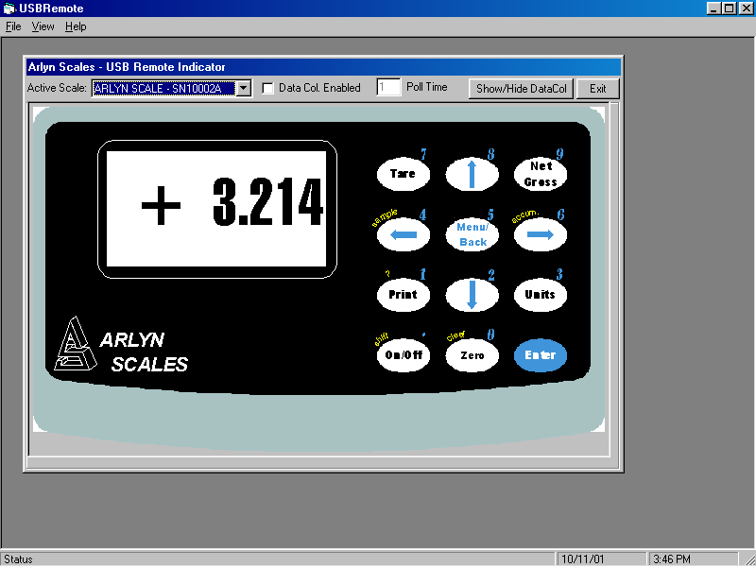
When the USB Remote Software is first started, you will be shown a blank screen with a number of menu items available. The software is now in its “Standby State”. The three menus that are available are File, View and Help.
Click on the menu item called View and then select Scale – Remote Screen. When you do this, a number of things happen.
First, the USB is scanned for any Arlyn Scales that may be attached to it. The program will then search its configuration records to find records, whose serial numbers match those that were scanned on the USB. If it finds those records it will load them, examine the previous configuration that was stored in that record and then configure the scale and the USB appropriately.
If this is the first time that the scale has been attached to the USB, there will be no configuration record for it. The program will then add a configuration record for this scale and assign it default values. Then it will link up with the scale and configure it appropriately. The default values for new scale configuration records can be modified and saved. This will be covered later.
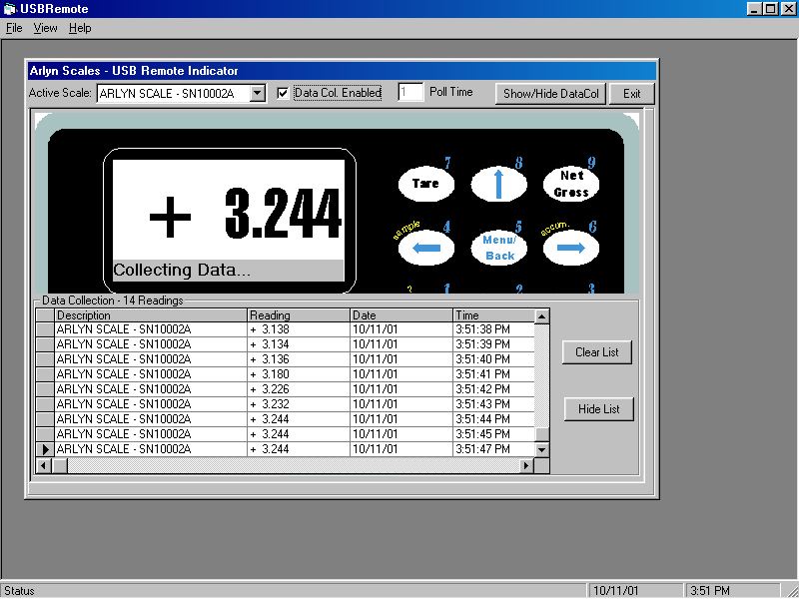
The Scale screen is similar to the one shown here. You will notice that it has a keyboard and display almost identical to the scale, and live readings will be displayed.
Just above the weight display is a pull down box listing all of the Arlyn Scales that were detected on the USB. To switch from one scale to another simply pull down the list and select the desired scale. The description of each scale, in part, is its serial number. This number can be found on the rear face of most Arlyn indicators. The serial number of the scale is automatically uploaded to the USB port on start-up.
Just to the right of the pull down list, there is a text box called Poll Time. This is how often the USB Software requests readings from the scale. Along with that you will see a check box to activate data collection for the selected scale. If you check this box, the bottom of the scale screen will be replaced with a data table containing the collected readings. You will see new readings being added to the table on each poll time interval. This collection record includes the scale’s ID, the reading, the time and the date that the reading was taken. If time and date are important in your application, ensure that the system time and date on your computer is set accurately.

The keyboard shown will emulate all normal keystroke presses as if they were pressed on the scale’s indicator itself. This keyboard, although fully functional will sometimes behave sluggishly depending on how the scale is configured and the rate at which the software requests readings from the scale. Just click on them slowly with your mouse and the key will activate. You may also key your way into the scale’s menu system and navigate around within it. The screen on your computer will not show the menu, and it must be viewed on the scale itself. The display update will stop while any menu is activated .

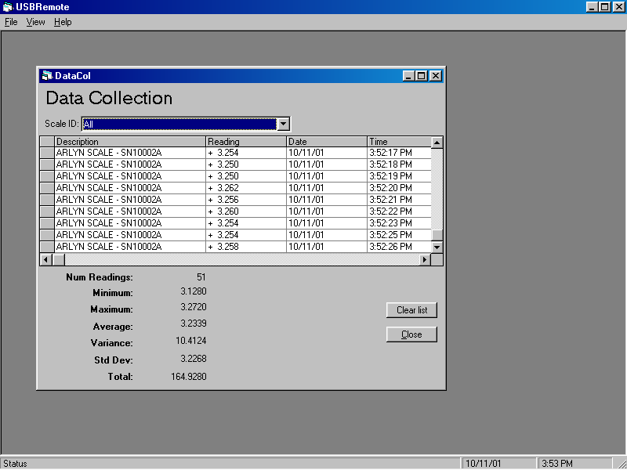
Data Collection
When activated for a particular scale, data will be collected and saved to a Microsoft Access 2.0 database file located in the USB Software’s installation directory. The name of the file is SCDATA.MDB. SCDATA.MDB contains only a single table called DataCol. There are five fields within DataCol. These are ID (record counter), ScaleID (scales description), Reading, Time and Date. This MDB file is not protected or encrypted in any way. One may import this table into any database application that is compatible with Microsoft Access to generate data queries, reports and the like.
Access 2.0, although updated many times throughout the years, was chosen specifically for this software. This allows anyone running later versions of Access to easily attach to, or import the table without having to worry about version conflicts. Microsoft Access has been upward compatible since its inception.
To view the Data Collection Table, pull down the VIEW menu and select Data Collection and then View/Edit.
The Data Collection Screen opens up showing the data stored there. Just above the table is a drop down list that will allow you to list all data, or data for a particular scale.
Below the table is a statistical analysis of the collected readings. One thing worth mentioning is that the statistical results will not operate when the totals of all the readings in the table are negative, or less than zero pounds.
Clicking the Clear List button will completely empty the table.

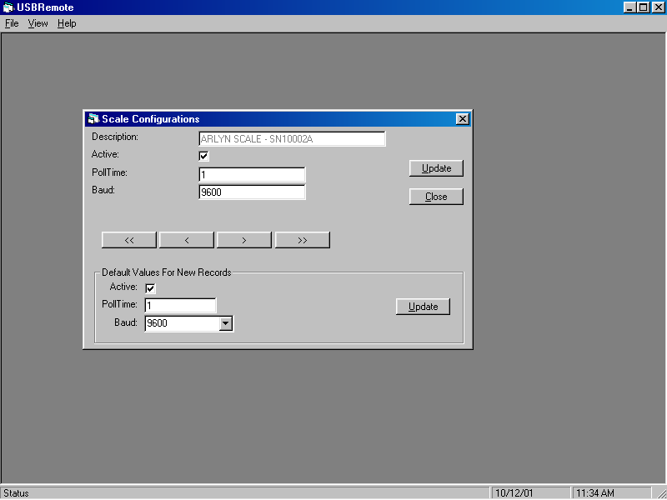
Scale Configurations and Defaults
As mentioned in an earlier section, the software maintains a configuration record for all the Arlyn Scales that are attached, or have ever been attached to it. These configuration records control whether the scale is active (yes, you can make any scale inactive), how often the software polls the scale for readings, and the speed (baud rate) at which the scales internal USB controller communicates with the scale’s main processor.
If the software detects a new scale on the USB, one that a configuration record doesn’t exist for yet, it will create one based on the defaults specified in the scale configuration screen. The defaults are factory set to have the scale active, poll readings each 1.0 second and internal communications set to 9600 baud.
To modify a scale’s configuration, start by opening the Scale Configuration Screen. Select VIEW from the main menu, and then select SCALE CONFIGURATIONS.
Use the navigation buttons to line up on the desired record, make whatever changes you like and then click the update button. You will notice the default values for new records on the lower half of the screen.
This screen can not be loaded while the Scale – Remote Screen is open. That screen must be closed before any configuration changes are made. This is because the USB scanning, configuration and record maintenance is done upon activation of the Scale – Remote Screen.

Exporting Data
Collected data can be exported to a CSV (comma separated values) text file. CSV is a standard export/import format recognized my most leading database applications today. A CSV file can also be directly loaded into Microsoft Excel.
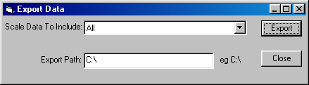
To activate the Export Screen, pull down the FILE menu and select EXPORT.
The list box near the top of the screen will allow you to select data from a specific scale, or data from all of the scales.

You must specify a valid export path before performing the export. A valid path or directory name may be used. Examples are: C:\ , C:\TEMPFILES\ etc.
When activated, a file called SCALEDATA.CSV is generated in the export path specified.

Installing the USB Drivers
The first step in the installation is to install the USB drivers on your computer.

If you downloaded the drivers from our web site, unzip the downloaded file into a temporary directory on your computer, or to a blank formatted floppy disk if you desire. The driver disk is also available from Arlyn Scales on a limited basis. In either case, place the floppy disk in the drive.
Apply power to the scale by plugging it into a wall outlet. The scale can be placed either in its normal weighing mode or at the “Ready” prompt.
Plug the USB cable from the indicator into the USB port on the back of the PC, or into the expander hub if you are using one.
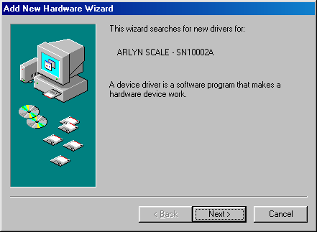
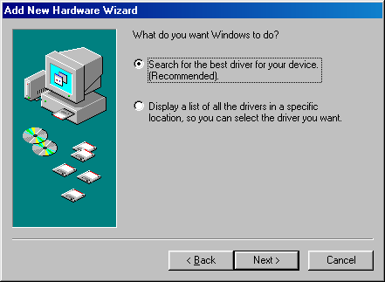

The Windows Operating System will automatically detect the new USB device and attempt to find a driver for it. The screen will look similar to this.
Click Next.
Select the search option on the next screen and click Next.

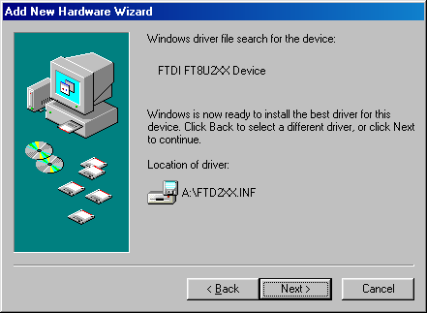
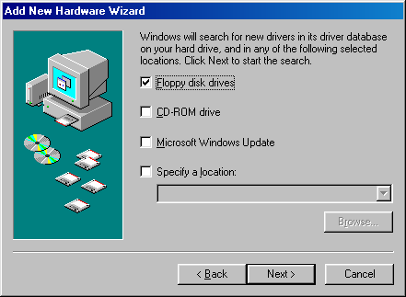
Place a check in Floppy Disk Drives, and then click Next.

After searching the floppy for driver files, you will be shown this screen. Click Next to install the drivers.

License Agreement – Technical Support

Before installing this software, please read, understand and accept the following agreement:

This software and its drivers are only available through Arlyn’s Web Site at www.arlynscales.com. Arlyn Scales doesn’t normally provide “Installation Disks”. All drivers and software should be downloaded from this site.
This software package is supplied free of charge “as is”. Arlyn Scales cannot, and will not offer technical support for the USB Remote Software. It was written simply as a service to our customers.
The actual USB drivers are written and distributed by FTDI, the makers of the USB controller chip that we use in our scale indicator. We have included the latest drivers from FTDI in this installation package. Future updates may be downloaded free of charge from their web site at www.ftdichip.com.

The system requirements are dictated by the drivers and their authors. Arlyn has no control over the update path or future availability of these drivers. Given that the drivers were written elsewhere, we cannot support them to any realistic degree. We have found that the people at FTDI are very cooperative with technical issues. For driver related technical issues, we generally have to defer to them.

Arlyn Scales does not warrant, guarantee or make any representations regarding the use, or results of the use of the Software or accompanying materials in terms of correctness, accuracy, reliability, currentness or otherwise. You assume all responsibility concerning selection of the software, and the ability to achieve the results you intend.
In no event shall Arlyn Scales, related companies, or its suppliers be liable for any damages whatsoever arising out of the use, or inability to use this software, even if Arlyn Scales has been advised of the possibilities of such damages.

By installing this software you acknowledge that you have read and agree to be bound by all of the terms of this agreement.

